Command Line Interface

Linux shell takes commands from the user and gives them to the kernel to execute. You can access the shell by opening your terminal located when you ‘Show Applications’ typically found on the bottom right of your screen. If you’re running Linux in Vscode or from GCP you can skip this step. This shell may also be referred to as the bash or ‘Bourne Again Shell’.
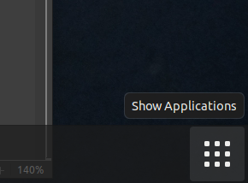
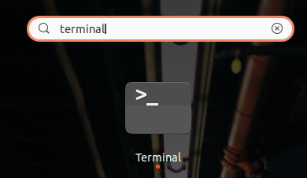
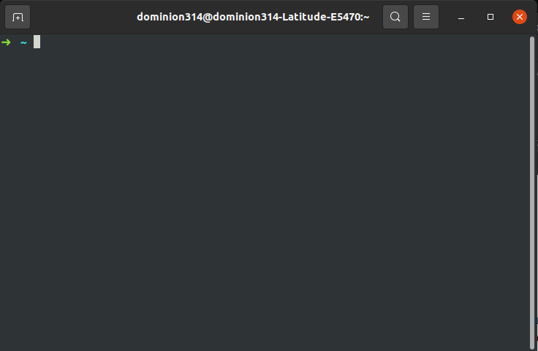

Commands you must know!

The following are the most used commands in Linux. If you can master these, you will be able to navigate the shell.

pwd shows the current directory you are in.
ls is the list command. It will show you the files, folders, and directories inside the system
cd .. is the change director command. Using two dots at the end moves you up one folder.
mv this is move. It allows the user to move a file from one folder to another. This is equivalent to dragging and dropping a file in Windows or Mac.
man this is the manual. Its used to show all the info for a particular command being used.
mkdir this is make directory. Used to make a new folder or directory
rmdir this is remove an EMPTY folder or directory.
touch creates a blank file.
rm this is to remove ANY folder, file, or directory.
locate this is to search for a file within the system.
clear this is to clear the screen.

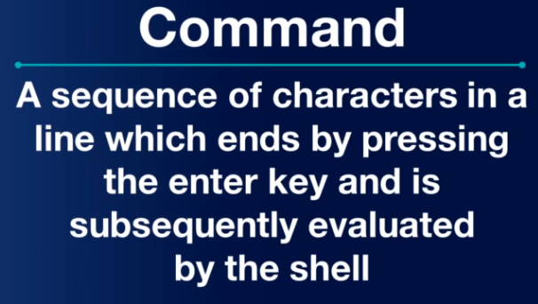
The reason most professionals rely on Linux or Mac for development is because of the ease of use via the command line. Whether you’re deploying code, troubleshooting networks, or administering Kubernetes – Linux is at the core of everything. For more popular Linux commands please refer to the following link:
https://www.reddit.com/r/linux/comments/b4khut/basic_linux_commands/

